# Data Preparation

Data Source: https://www.kaggle.com/datasets/fedesoriano/stroke-prediction-dataset

# Data Understanding

# Data Preprocessing

# Model 1 (Logistic Regression):

## Model Preparation

* Split x to y parameters

|  |
| --- |
| y = numerical_columns['stroke']  X = numerical_columns.drop(columns=['stroke']) |

* Split to train, test, val

|  |
| --- |
| X_train, X_test, y_train, y_test = train_test_split(X, y, test_size=0.051, random_state=5) |

* Normalize x value

|  |
| --- |
| scaler = StandardScaler()  X_train_scaled = scaler.fit_transform(X_train)  X_test_scaled = scaler.transform(X_test) |

* Create model

|  |
| --- |
| lr_model = LogisticRegression(class_weight='balanced')  lr_model.fit(X_train_scaled, y_train) |

## Model Train

|  |
| --- |
| lr_model.score( X_test_scaled, y_test) |

## Model Result

Model accuracy: 0.7290836653386454

|  |  |  |  |  |
| --- | --- | --- | --- | --- |
|  | precision | recall | f1-score | support |
| No Stroke | 0.99 | 0.73 | 0.84 | 245 |
| Stroke | 0.07 | 0.83 | 0.13 | 6 |
| accuracy |  |  | 0.73 | 251 |
| macro avg | 0.53 | 0.78 | 0.48 | 251 |
| weighted avg | 0.97 | 0.73 | 0.82 | 251 |

## Optimize Model

Logistic Regression tidak optimal untuk data yang imbalance. Karena daset dengan label “Stroke” (6 data) dan “No Stroke” (245 data) memiliki jumlah yang tidak balance, sehingga perlu dilakukan balancing data sebelum train&test model.

* Tahap balancing data menggunakan SMOTE (Synthetic Minority Over-sampling Technique)

Code:

|  |
| --- |
| from imblearn.over_sampling import SMOTE  sm = SMOTE()  X_resampled, y_resampled = sm.fit_resample(X, y) |

## Model Train after optimized

|  |
| --- |
| lr_model.score( X_test_scaled, y_test) |

## Model Result after optimized

Model Accuracy: 0.8916666666666667

|  |  |  |  |  |
| --- | --- | --- | --- | --- |
|  | precision | recall | f1-score | support |
| No Stroke | 0.91 | 0.87 | 0.89 | 236 |
| Stroke | 0.88 | 0.91 | 0.90 | 244 |
| accuracy |  |  | 0.89 | 480 |
| macro avg | 0.89 | 0.89 | 0.89 | 480 |
| weighted avg | 0.89 | 0.89 | 0.89 | 480 |

## Reference:

# Model 2 (Random Forest)

## Model Preparation

* Split x to y parameters

|  |
| --- |
| y = numerical_columns['stroke']  X = numerical_columns.drop(columns=['stroke']) |

* Split to train, test, val

|  |
| --- |
| X_train, X_test, y_train, y_test = train_test_split(X, y, test_size=0.051, random_state=1) |

* Normalize x value

|  |
| --- |
| scaler = StandardScaler()  X_train_scaled = scaler.fit_transform(X_train)  X_test_scaled = scaler.transform(X_test) |

* Create model

|  |
| --- |
| rforest_model = RandomForestClassifier(class_weight='balanced')  rforest_model.fit(X_train_scaled, y_train) |

## Model Train

|  |
| --- |
| rforest_model.score(X_test_scaled, y_test) |

## Model Result

Model Accuracy: 0.9800796812749004

|  |  |  |  |  |
| --- | --- | --- | --- | --- |
|  | precision | recall | f1-score | support |
| No Stroke | 0.98 | 1.0 | 0.99 | 246 |
| Stroke | 0.00 | 0.00 | 0.00 | 5 |
| accuracy |  |  | 0.98 | 251 |
| macro avg | 0.49 | 0.50 | 0.49 | 251 |
| weighted avg | 0.96 | 0.98 | 0.97 | 251 |

## Optimize Model

Dari hasil akurasi, meskipun akurasi yang didapat memiliki nilai yang tinggi, namun model randomforest tidak dapat mendeteksi/menganalisa value label 1 (Stroke). Hal ini disebabkan karena dataset yang imbalance antara value 1(stroke) dan 0 (Non stroke).

* Balancing dataset dapat dilakukan dengan SMOTE (Synthetic Minority Over-sampling Technique)

Code:

|  |
| --- |
| from imblearn.over_sampling import SMOTE  sm = SMOTE()  X_resampled, y_resampled = sm.fit_resample(X, y) |

## Model Train after optimized

|  |
| --- |
| rforest_model.score(X_test_scaled, y_test) |

## Model Result after optimized

Model Accuracy: 0.970

|  |  |  |  |  |
| --- | --- | --- | --- | --- |
|  | precision | recall | f1-score | support |
| No Stroke | 0.96 | 0.98 | 0.97 | 233 |
| Stroke | 0.98 | 0.96 | 0.97 | 247 |
| accuracy |  |  | 0.97 | 480 |
| macro avg | 0.97 | 0.97 | 0.97 | 480 |
| weighted avg | 0.97 | 0.97 | 0.97 | 480 |

## Reference:

# Model 3 (Deep Learning Using Sequential Models)

## Model Preparation

* Split x to y parameters

|  |
| --- |
| y = numerical_columns['stroke']  X = numerical_columns.drop(columns=['stroke']) |

* Split to train, test, val

|  |
| --- |
| X_train, X_test, y_train, y_test = train_test_split(X, y, test_size=0.63, shuffle=True, random_state=21) |

* Normalize x value

|  |
| --- |
| scaler = StandardScaler()  X_train_scaled = scaler.fit_transform(X_train)  X_test_scaled = scaler.transform(X_test) |

* Create model

|  |
| --- |
| model = Sequential()  model.add(Dense(16, activation='relu', input_dim=X_train_scaled.shape[1]))  model.add(Dense(50, activation="relu"))  model.add(Dense(20, activation="relu"))  model.add(Dropout(0.25))  model.add(Dense(1, activation="sigmoid"))  print (model.summary()) |

## Model Train

|  |
| --- |
| Epoch 1/10  **18/18** ━━━━━━━━━━━━━━━━━━━━ **2s** 18ms/step - accuracy: 0.8936 - loss: 0.4938 - val_accuracy: 0.9532 - val_loss: 0.3116  Epoch 2/10  **18/18** ━━━━━━━━━━━━━━━━━━━━ **0s** 6ms/step - accuracy: 0.9549 - loss: 0.2999 - val_accuracy: 0.9532 - val_loss: 0.2337  Epoch 3/10  **18/18** ━━━━━━━━━━━━━━━━━━━━ **0s** 7ms/step - accuracy: 0.9553 - loss: 0.2241 - val_accuracy: 0.9532 - val_loss: 0.2142  Epoch 4/10  **18/18** ━━━━━━━━━━━━━━━━━━━━ **0s** 6ms/step - accuracy: 0.9699 - loss: 0.1559 - val_accuracy: 0.9532 - val_loss: 0.2036  Epoch 5/10  **18/18** ━━━━━━━━━━━━━━━━━━━━ **0s** 7ms/step - accuracy: 0.9609 - loss: 0.1705 - val_accuracy: 0.9532 - val_loss: 0.1918  Epoch 6/10  **18/18** ━━━━━━━━━━━━━━━━━━━━ **0s** 7ms/step - accuracy: 0.9626 - loss: 0.1576 - val_accuracy: 0.9532 - val_loss: 0.1855  Epoch 7/10  **18/18** ━━━━━━━━━━━━━━━━━━━━ **0s** 7ms/step - accuracy: 0.9551 - loss: 0.1627 - val_accuracy: 0.9532 - val_loss: 0.1822  Epoch 8/10  **18/18** ━━━━━━━━━━━━━━━━━━━━ **0s** 7ms/step - accuracy: 0.9618 - loss: 0.1431 - val_accuracy: 0.9532 - val_loss: 0.1806  Epoch 9/10  **18/18** ━━━━━━━━━━━━━━━━━━━━ **0s** 7ms/step - accuracy: 0.9518 - loss: 0.1736 - val_accuracy: 0.9532 - val_loss: 0.1801  Epoch 10/10  **18/18** ━━━━━━━━━━━━━━━━━━━━ **0s** 7ms/step - accuracy: 0.9567 - loss: 0.1428 - val_accuracy: 0.9532 - val_loss: 0.1801 |

## Model Result

Loss Graph

Accuracy Graph:

Model accuracy: 0.9586162567138672

Classification Report:

|  |  |  |  |  |
| --- | --- | --- | --- | --- |
|  | precision | recall | f1-score | support |
| No Stroke | 0.96 | 1.00 | 0.98 | 2965 |
| Stroke | 0.00 | 0.00 | 0.00 | 128 |
| accuracy |  |  | 0.96 | 3093 |
| macro avg | 0.48 | 0.50 | 0.49 | 3093 |
| weighted avg | 0.92 | 0.96 | 0.94 | 3093 |

Confusion Matrix:

## Optimize Model

Meskipun model memiliki akurasi yang tinggi, namun model belum dapat mendeteksi Stroke. Hasil grafik accuracy juga menunjukkan tidak ada peningkatan akurasi. Hal ini dikarenakan imbalance dataset yang membuat model hanya memprediksi label yang lebih besar (label No Stroke).

Langkah optimasi:

* Menggunakan SMOTE untuk menyamakan ukuran data label Stroke dan No Stroke

|  |
| --- |
| from imblearn.over_sampling import SMOTE  sm = SMOTE()  X_resampled, y_resampled = sm.fit_resample(X, y) |

* Menaikkan/menambah Dense layer

|  |
| --- |
| model = Sequential()  model.add(Dense(16, activation='relu', input_dim=X_train_scaled.shape[1]))  model.add(Dense(50, activation="relu"))  model.add(Dense(20, activation="relu"))  model.add(Dropout(0.25))  model.add(Dense(23, activation="relu"))  model.add(Dense(1, activation="sigmoid"))  print (model.summary()) |

* Mengurangi test size, randomstate

|  |
| --- |
| X_train, X_test, y_train, y_test = train_test_split(X_resampled, y_resampled, test_size=0.04, shuffle=True, random_state=12) |

## Model Train after optimized

|  |
| --- |
| Epoch 1/10  **85/85** ━━━━━━━━━━━━━━━━━━━━ **2s** 6ms/step - accuracy: 0.6433 - loss: 0.6376 - val_accuracy: 0.8263 - val_loss: 0.3883  Epoch 2/10  **85/85** ━━━━━━━━━━━━━━━━━━━━ **0s** 3ms/step - accuracy: 0.8331 - loss: 0.3729 - val_accuracy: 0.8596 - val_loss: 0.3159  Epoch 3/10  **85/85** ━━━━━━━━━━━━━━━━━━━━ **0s** 3ms/step - accuracy: 0.8548 - loss: 0.3290 - val_accuracy: 0.8706 - val_loss: 0.2950  Epoch 4/10  **85/85** ━━━━━━━━━━━━━━━━━━━━ **0s** 3ms/step - accuracy: 0.8772 - loss: 0.3015 - val_accuracy: 0.8789 - val_loss: 0.2811  Epoch 5/10  **85/85** ━━━━━━━━━━━━━━━━━━━━ **0s** 3ms/step - accuracy: 0.8792 - loss: 0.3004 - val_accuracy: 0.8850 - val_loss: 0.2723  Epoch 6/10  **85/85** ━━━━━━━━━━━━━━━━━━━━ **0s** 3ms/step - accuracy: 0.8928 - loss: 0.2665 - val_accuracy: 0.8881 - val_loss: 0.2626  Epoch 7/10  **85/85** ━━━━━━━━━━━━━━━━━━━━ **0s** 3ms/step - accuracy: 0.9026 - loss: 0.2572 - val_accuracy: 0.8900 - val_loss: 0.2586  Epoch 8/10  **85/85** ━━━━━━━━━━━━━━━━━━━━ **0s** 3ms/step - accuracy: 0.9027 - loss: 0.2542 - val_accuracy: 0.8994 - val_loss: 0.2530  Epoch 9/10  **85/85** ━━━━━━━━━━━━━━━━━━━━ **0s** 3ms/step - accuracy: 0.9039 - loss: 0.2462 - val_accuracy: 0.8983 - val_loss: 0.2534  Epoch 10/10  **85/85** ━━━━━━━━━━━━━━━━━━━━ **0s** 3ms/step - accuracy: 0.9097 - loss: 0.2335 - val_accuracy: 0.9017 - val_loss: 0.2475 |

## Model Result after optimized

Loss Graph:

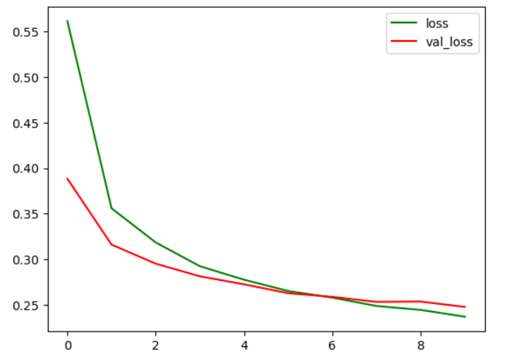

Accuracy Graph:

Model accuracy: 0.9095744490623474

|  |  |  |  |  |
| --- | --- | --- | --- | --- |
|  | precision | recall | f1-score | support |
| No Stroke | 0.92 | 0.90 | 0.91 | 190 |
| Stroke | 0.90 | 0.92 | 0.91 | 186 |
| accuracy |  |  | 0.91 | 376 |
| macro avg | 0.91 | 0.91 | 0.91 | 376 |
| weighted avg | 0.91 | 0.91 | 0.91 | 376 |

Confusion Matrix:

## Reference:

# Model 4 (Deep Learning Using TabNetClassifier)

## Model Preparation

* Split x and y parameters

|  |
| --- |
| X = numerical_columns.drop(columns=['stroke'])  y = data['stroke'] |

* Split to train, test, val

|  |
| --- |
| X_train, X_test, y_train, y_test = train_test_split(X, y, test_size=0.87, random_state=45, stratify=y) |

* Normalize x value

|  |
| --- |
| scaler = StandardScaler()  X_train_scaled = scaler.fit_transform(X_train)  X_test_scaled = scaler.transform(X_test) |

* Create model

|  |
| --- |
| clf = TabNetClassifier(verbose=3, seed=100) |

* Calculate class weight

|  |
| --- |
| class_weights = compute_class_weight(class_weight='balanced', classes=np.unique(y_train_np), y=y_train_np)  weights_dict = {i: class_weights[i] for i in range(len(class_weights))} |

* Create train model

|  |
| --- |
| clf.fit(  X_train_np, y_train_np,  eval_set=[(X_test_np, y_test_np)],  max_epochs=60,  patience=10,  batch_size=400,  virtual_batch_size=200,  weights=weights_dict,  eval_metric=['accuracy']  ) |

## Model Train

|  |
| --- |
| epoch 0 | loss: 0.73233 | val_0_accuracy: 0.50995 | 0:00:00s  epoch 3 | loss: 0.55627 | val_0_accuracy: 0.56872 | 0:00:00s  epoch 6 | loss: 0.47698 | val_0_accuracy: 0.6207 | 0:00:01s  epoch 9 | loss: 0.42488 | val_0_accuracy: 0.66191 | 0:00:02s  epoch 12 | loss: 0.3445 | val_0_accuracy: 0.67853 | 0:00:03s  epoch 15 | loss: 0.402 | val_0_accuracy: 0.70311 | 0:00:03s  epoch 18 | loss: 0.31994 | val_0_accuracy: 0.7174 | 0:00:04s  epoch 21 | loss: 0.23884 | val_0_accuracy: 0.7195 | 0:00:05s  epoch 24 | loss: 0.24585 | val_0_accuracy: 0.75018 | 0:00:05s  epoch 27 | loss: 0.27238 | val_0_accuracy: 0.78881 | 0:00:06s  epoch 30 | loss: 0.20849 | val_0_accuracy: 0.78928 | 0:00:07s  epoch 33 | loss: 0.18627 | val_0_accuracy: 0.75205 | 0:00:07s  epoch 36 | loss: 0.2489 | val_0_accuracy: 0.75252 | 0:00:08s  Early stopping occurred at epoch 38 with best_epoch = 28 and best_val_0_accuracy = 0.79653 |

## Model Result

Model accuracy: 0.7965347693748537

Loss:

Loss & Val:

Classification Report:

|  |  |  |  |  |
| --- | --- | --- | --- | --- |
|  | precision | recall | f1-score | support |
| No Stroke | 0.97 | 0.81 | 0.88 | 4089 |
| Stroke | 0.08 | 0.38 | 0.14 | 182 |
| accuracy |  |  | 0.80 | 4271 |
| macro avg | 0.53 | 0.60 | 0.51 | 4271 |
| weighted avg | 0.93 | 0.80 | 0.85 | 4271 |

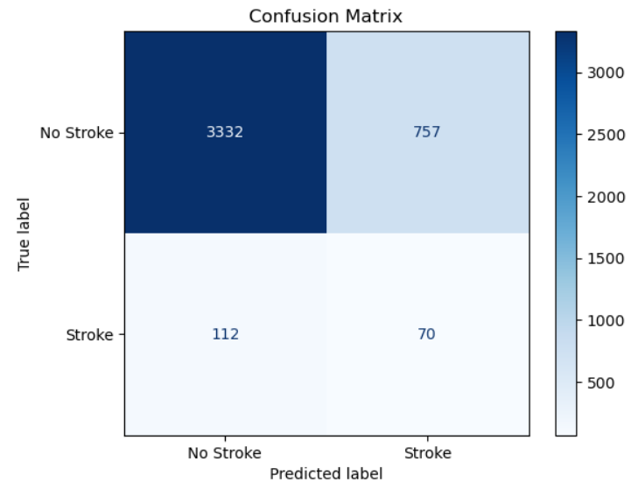

## Optimize Model

Dari akurasi yang didapatkan, model masih dapat ditingkatkan akurasinya. Akurasi yang didapatkan sudah baik (0.8 / 80%). Akan tetapi data akurasi dan data confusion matrix mendapatkan hasil yang kurang baik. Perbedaan persebaran data yang terlalu besar yaitu 4000 data ‘No Stroke’ dan 182 data ‘Stroke’. Untuk meningkatkan akurasi dari model, dapat dilakukan dengan beberapa cara yaitu:

* Menggunakan SMOTE untuk mengolah data yang ada supaya balance
* Mengurangi jumlah dataset

## Model Train after optimized

|  |
| --- |
| X_train, X_test, y_train, y_test = train_test_split(X_resampled, y_resampled, test_size=0.02, random_state=45, stratify=y_resampled) |

|  |
| --- |
| epoch 0 | loss: 0.46002 | val_0_accuracy: 0.82447 | 0:00:00s  epoch 3 | loss: 0.3322 | val_0_accuracy: 0.8883 | 0:00:03s  epoch 6 | loss: 0.27599 | val_0_accuracy: 0.87234 | 0:00:05s  epoch 9 | loss: 0.24425 | val_0_accuracy: 0.93617 | 0:00:08s  epoch 12 | loss: 0.23396 | val_0_accuracy: 0.95213 | 0:00:11s  epoch 15 | loss: 0.23857 | val_0_accuracy: 0.90426 | 0:00:13s  epoch 18 | loss: 0.22647 | val_0_accuracy: 0.91489 | 0:00:16s  epoch 21 | loss: 0.22596 | val_0_accuracy: 0.93085 | 0:00:18s  Early stopping occurred at epoch 22 with best_epoch = 12 and best_val_0_accuracy = 0.95213 |

## Model Result after optimized

Model accuracy: 95.21

Val_Accuracy

Val_Loss:

Classification Report:

|  |  |  |  |  |
| --- | --- | --- | --- | --- |
|  | precision | recall | f1-score | support |
| No Stroke | 0.97 | 0.94 | 0.95 | 94 |
| Stroke | 0.94 | 0.97 | 0.95 | 94 |
| accuracy |  |  | 0.95 | 188 |
| macro avg | 0.53 | 0.60 | 0.51 | 188 |
| weighted avg | 0.93 | 0.80 | 0.85 | 188 |

## Reference:

# Model 5 (Xai SHAP LogisticRegression)

## Model Preparation

* Shap explainer

|  |
| --- |
| explainer = shap.Explainer(lr_model, X_train_scaled)  shap_values = explainer(X_test_scaled) |

## Model Result

Model Accuracy: 0.8791666666666667

|  |  |  |  |  |
| --- | --- | --- | --- | --- |
|  | precision | recall | f1-score | support |
| No Stroke | 0.89 | 0.86 | 0.88 | 236 |
| Stroke | 0.87 | 0.89 | 0.88 | 244 |
| accuracy |  |  | 0.88 | 480 |
| macro avg | 0.88 | 0.88 | 0.88 | 480 |
| weighted avg | 0.88 | 0.88 | 0.88 | 480 |

* Shap Summary Plot:

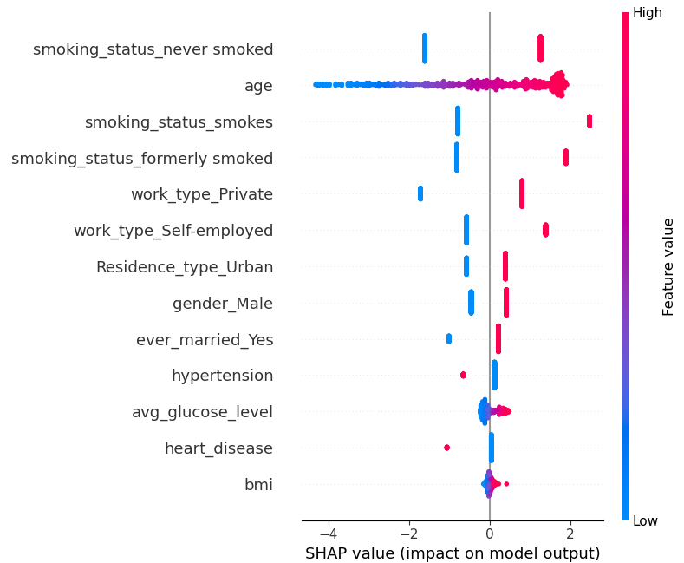

* Shap Force Plot:

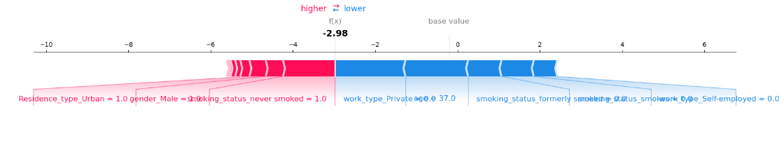

* Shap Coeficient:

## Analyze SHAP

* Model Coefficient Analyze

|  |  |  |  |
| --- | --- | --- | --- |
| Feature | Coefficient | Absolute_Coefficient | Odds_Ratio |
| age | 1.692851 | 1.692851 | 5.434952 |
| smoking_status_never smoked | 1.43751 | 1.43751 | 4.210199 |
| smoking_status_smokes | 1.385832 | 1.385832 | 3.998151 |
| smoking_status_formerly smoked | 1.260527 | 1.260527 | 3.527281 |
| work_type_Private | 1.1532 | 1.1532 | 3.168317 |
| work_type_Self-employed | 0.879443 | 0.879443 | 2.409556 |
| ever_married_Yes | 0.47965 | 0.47965 | 1.615509 |
| Residence_type_Urban | 0.468729 | 0.468729 | 1.597962 |
| gender_Male | 0.436685 | 0.436685 | 1.547569 |
| heart_disease | -0.23734 | 0.237336 | 0.788726 |
| hypertension | -0.2209 | 0.220903 | 0.801795 |
| avg_glucose_level | 0.186979 | 0.186979 | 1.205602 |
| bmi | 0.059518 | 0.059518 | 1.061325 |

* Coeficeient tertinggi merupakan parameter yang dapat menyebabkan stroke.  
  Dari table coefficient, Age memiliki nilai koefisien tertinggi (Usia menyebabkan stroke). Sedangkan nilai negative merupakan koefisien terendah/ tidak berkorelasi secara langsung terhadap akurasi penyebab stroke.

## Reference:

https://www.datacamp.com/tutorial/introduction-to-shap-values-machine-learning-interpretability

# Model 6 (Xai Lime)

## Model Preparation

* Lime Explainer

|  |
| --- |
| explainer = lime.lime_tabular.LimeTabularExplainer(  X_train_scaled,  feature_names=X.columns,  class_names=['No Stroke', 'Stroke'],  mode='classification',  discretize_continuous=True  ) |

* Lime Model Creation

|  |
| --- |
| exp = explainer.explain_instance(X_test_scaled[0], lr_model.predict_proba, num_features=10) |

## Model Result

## Analyze Lime

* Untuk summary keseluruhan

* Untuk 1 sample data missdetection:

## Reference:

https://medium.com/data-science/lime-explain-machine-learning-predictions-af8f18189bfe